**NIAGARA INVERTER CEILING FANS:**

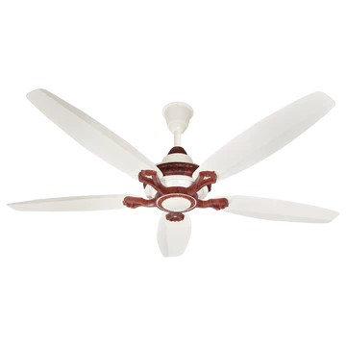

**Price: 12,895.00**

Niagara Inverter Ceiling Fans are a masterpiece of modern cooling technology, combining sleek designs with cutting-edge energy efficiency. Equipped with advanced inverter motors, these fans optimize airflow while minimizing power consumption, resulting in significant energy savings. With features such as whisper-quiet operation, variable speed control, and reversible functionality, Niagara Inverter Ceiling Fans provide unparalleled comfort and flexibility. Their robust construction, rust-resistant coating, and elegant designs ensure a long-lasting and visually stunning addition to any room. Ideal for residential and commercial spaces, Niagara Inverter Ceiling Fans offer a perfect blend of style, substance, and sustainability, making them a superior choice for those seeking a reliable and eco-friendly cooling solution.

**Key features of niagara inverter ceiling fans include:**

* **Inverter Motor:** Energy-efficient and quiet performance.
* **Remote Control:** Easy adjustment of speed and settings from a distance.
* **Multiple Speed Settings:** Customizable airflow options for comfort.
* **Durable Design:** Long-lasting build with quality materials.
* **Reversible Function:** Changes direction for year-round air circulation.
* **Sleek Aesthetic:** Stylish, modern design to suit various interiors.
* **Energy Efficient:** Lower power consumption for cost savings.

Top of FormBottom of Form